1. Implement transmission of ping messages/trace route over a network topology consisting of 6 nodes and find the number of packets dropped due to congestion.

set ns [new Simulator]

set tf [open lab2.tr w]

$ns trace-all $tf

set nf [open lab2.nam w]

$ns namtrace-all $nf

set n0 [$ns node]

set n1 [$ns node]

set n2 [$ns node]

set n3 [$ns node]

set n4 [$ns node]

set n5 [$ns node]

set n6 [$ns node]

$n0 label "Ping0"

$n4 label "Ping4"

$n5 label "Ping5"

$n6 label "Ping6"

$n2 label "Router"

$ns color 1 "red"

$ns color 2 "green"

$ns duplex-link $n0 $n2 100Mb 300ms DropTail

$ns duplex-link $n1 $n2 1Mb 300ms DropTail

$ns duplex-link $n3 $n2 1Mb 300ms DropTail

$ns duplex-link $n5 $n2 100Mb 300ms DropTail

$ns duplex-link $n2 $n4 1Mb 300ms DropTail

$ns duplex-link $n2 $n6 1Mb 300ms DropTail

$ns queue-limit $n0 $n2 5

$ns queue-limit $n2 $n4 3

$ns queue-limit $n2 $n6 2

$ns queue-limit $n5 $n2 5

#The below code is used to connect between the ping agents to the node n0, #n4 , n5 and n6.

set ping0 [new Agent/Ping]

$ns attach-agent $n0 $ping0

set ping4 [new Agent/Ping]

$ns attach-agent $n4 $ping4

set ping5 [new Agent/Ping]

$ns attach-agent $n5 $ping5

set ping6 [new Agent/Ping]

$ns attach-agent $n6 $ping6

$ping0 set packetSize_ 50000

$ping0 set interval_ 0.0001

$ping5 set packetSize_ 60000

$ping5 set interval_ 0.00001

$ping0 set class_ 1

$ping5 set class_ 2

$ns connect $ping0 $ping4

$ns connect $ping5 $ping6

#Define a 'recv' function for the class 'Agent/Ping'

#The below function is executed when the ping agent receives a reply from the destination

Agent/Ping instproc recv {from rtt} {

$self instvar node_

puts " The node [$node_ id] received an reply from $from with round trip time of $rtt"

}

proc finish {} {

global ns nf tf

exec nam lab2.nam &

$ns flush-trace

close $tf

close $nf

exit 0

}

#Schedule events

$ns at 0.1 "$ping0 send"

$ns at 0.2 "$ping0 send"

$ns at 0.3 "$ping0 send"

$ns at 0.4 "$ping0 send"

$ns at 0.5 "$ping0 send"

$ns at 0.6 "$ping0 send"

$ns at 0.7 "$ping0 send"

$ns at 0.8 "$ping0 send"

$ns at 0.9 "$ping0 send"

$ns at 1.0 "$ping0 send"

$ns at 1.1 "$ping0 send"

$ns at 1.2 "$ping0 send"

$ns at 1.3 "$ping0 send"

$ns at 1.4 "$ping0 send"

$ns at 1.5 "$ping0 send"

$ns at 1.6 "$ping0 send"

$ns at 1.7 "$ping0 send"

$ns at 1.8 "$ping0 send"

$ns at 0.1 "$ping5 send"

$ns at 0.2 "$ping5 send"

$ns at 0.3 "$ping5 send"

$ns at 0.4 "$ping5 send"

$ns at 0.5 "$ping5 send"

$ns at 0.6 "$ping5 send"

$ns at 0.7 "$ping5 send"

$ns at 0.8 "$ping5 send"

$ns at 0.9 "$ping5 send"

$ns at 1.0 "$ping5 send"

$ns at 1.1 "$ping5 send"

$ns at 1.2 "$ping5 send"

$ns at 1.3 "$ping5 send"

$ns at 1.4 "$ping5 send"

$ns at 1.5 "$ping5 send"

$ns at 1.6 "$ping5 send"

$ns at 1.7 "$ping5 send"

$ns at 1.8 "$ping5 send"

$ns at 5.0 "finish"

$ns run

**AWK:**

BEGIN{

count=0;

}

{

if($1=="d")

count++;

}

END{

printf("The Total no of Packets Drop is :%d\n\n", count);

}

Topology:

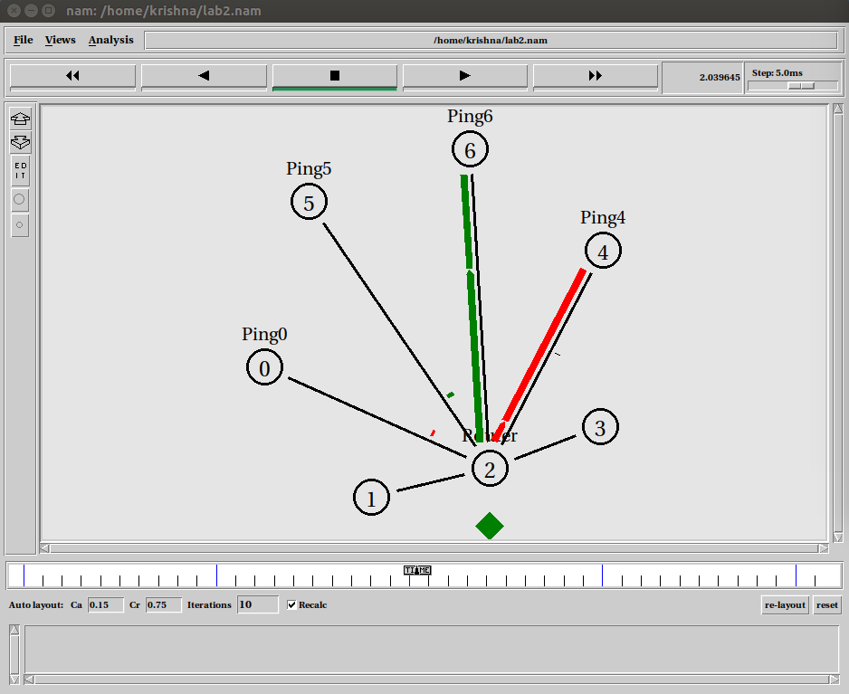

Output:

